**Homework 3**

Remember that your programs must read the data from the text files exactly as they appear. You may not edit the text files to make them more convenient for SAS. Turn in the code, log file and output. If any of these 3 items is missing then you will not be graded for that question. Use the snipping tool instead of screen shots and make sure the font is large enough for me to read.

1. Refer to the AIRPORTS dataset. Write a SAS program to read the data file from your diskette with an INFILE statement, store a permanent SAS dataset on your diskette, and print the dataset. There should be five variables (three character and two numeric) and 20 observations.

**CODE-**

**data** airport;

infile '\\Client\C$\Users\Leland\Desktop\ISM6930 SAS\Lesson 3\Homework\airport.csv' dlm = ',' firstobs=**2** dsd ;

input city :$30. state $ abrev $ pass95 pass85;

**run**;

libname homework '\\Client\C$\Users\Leland\Desktop';

**data** homework.airports;

set airport;

**proc** **print** data = homework.airports;

title 'airports';

**run**;

**LOG**

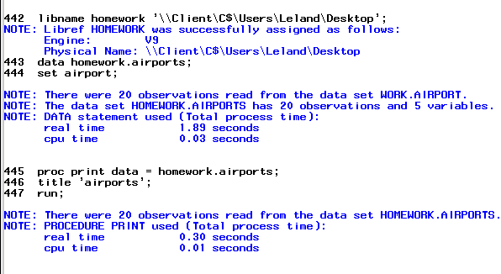

**OUTPUT**

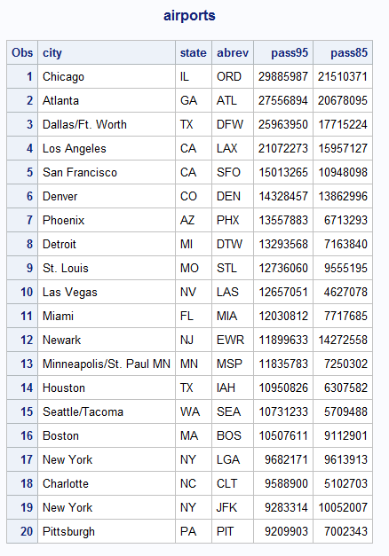

1. Refer to the RYAN dataset. Write a SAS program to read the data file from your USB with an INFILE statement and print the dataset. There should be four variables (one character and three numeric) and 21 observations.

**CODE**

**data** ryan;

infile '\\Client\C$\Users\Leland\Desktop\ISM6930 SAS\Lesson 3\Homework\ryan.txt' dlm='09'x firstobs=**2** missover ;

input TITLE :$30. ROGER NYTIMES USAT ;

**run**;

**proc** **print** data= ryan;

title 'ryan';

**run**;

**LOG**

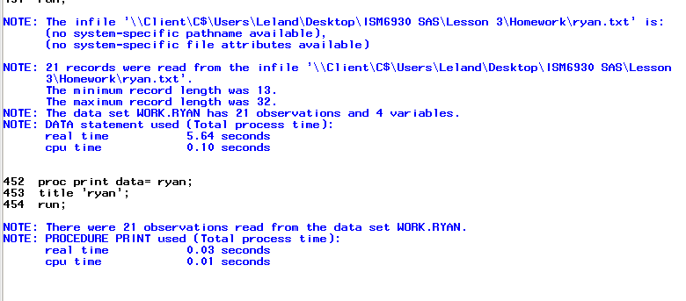

**OUTPUT**

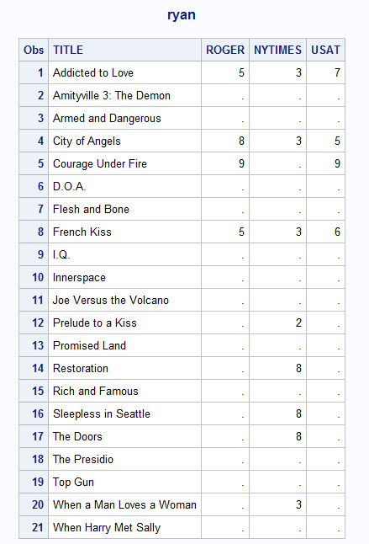

1. Refer to the HOCKEY dataset. Write a SAS program to read the data file from your USB with an INFILE statement and print dataset. Combine the month, day, and year into one variable representing the date. There should be six variables (three character and three numeric) and 37 observations.

**CODE**

**data** hockey;

infile '\\Client\C$\Users\Leland\Desktop\ISM6930 SAS\Lesson 3\Homework\hockey.csv'

dlm=',' firstobs=**2** dsd;

input Date :$10. Team :$20. City :$20. State :$15. OSU OPP ;

**run**;

**proc** **print** data= hockey;

title 'hockey';

**run**;

**LOG**

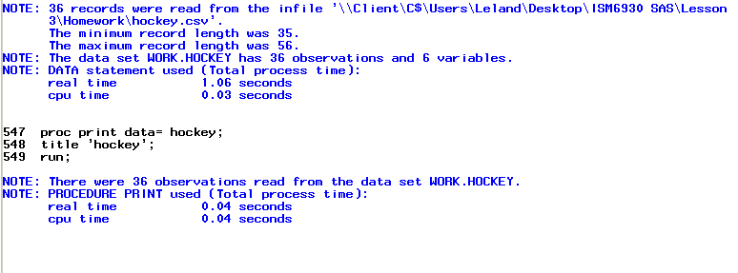

**OUTPUT**

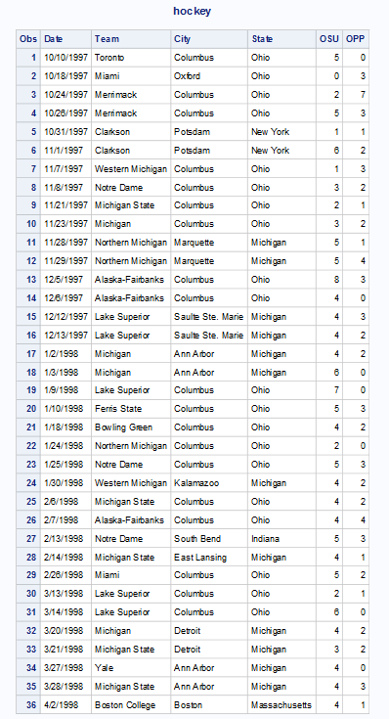

1. Refer to the LIMES dataset. Write a SAS program to read the data file from your USB with an INFILE statement and print dataset. Combine the month, day, and year into one variable representing the date.

**CODE**

**data** limes;

infile '\\Client\C$\Users\Leland\Desktop\ISM6930 SAS\Lesson 3\Homework\limes.txt'

dlm=',' firstobs=**2** dsd;

input Date :MMDDYY10. FruitDia FruitLength FruitWt FruitVol JuiceVol JuiceWt PeelWt ;

format date MMDDYY8.

run;

**proc** **print** data= limes;

title 'limes';

**run**;

**LOG**

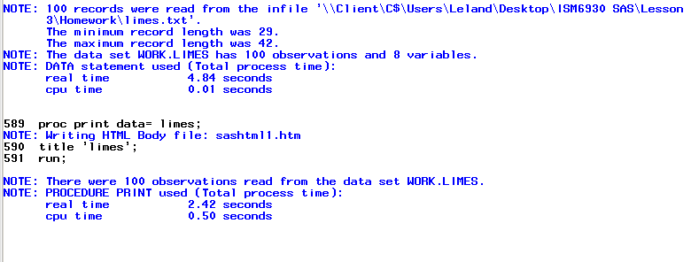

**OUTPUT** 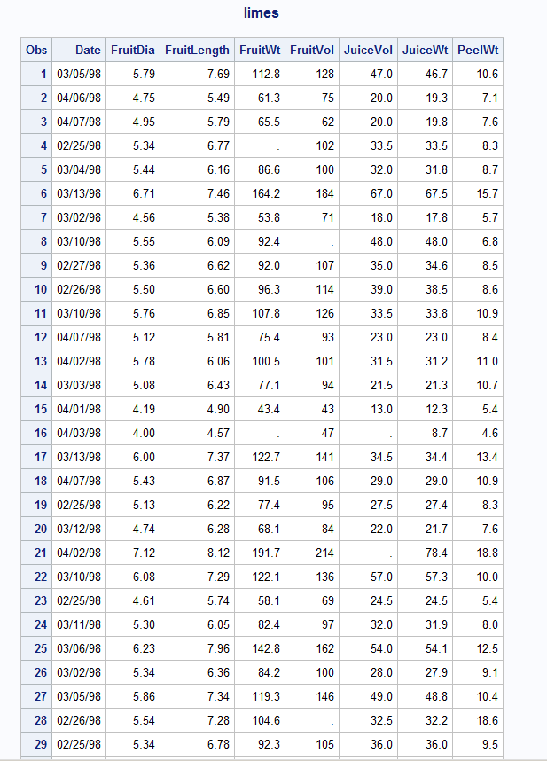

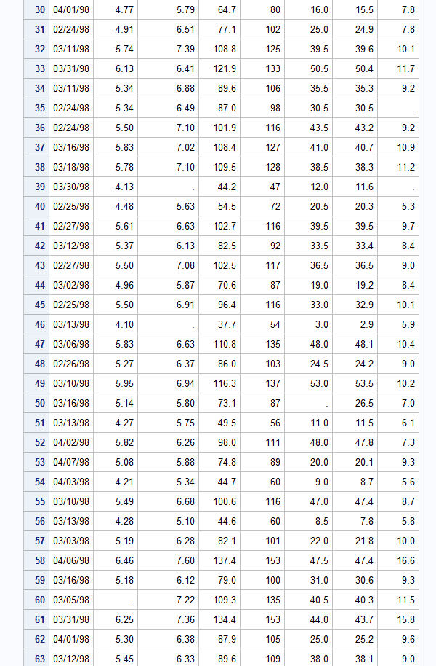

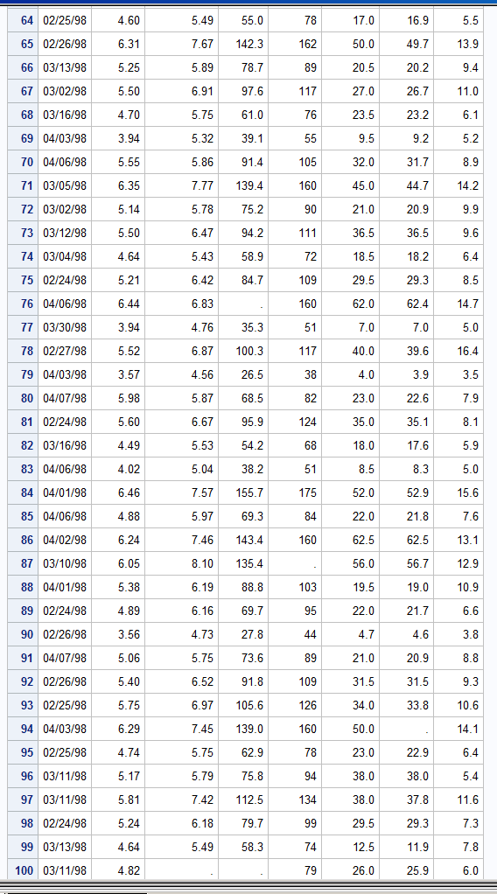

1. Refer to the HANKS dataset. Write a SAS program to read the data file from your USB with an INFILE statement and print the dataset. There should be 11 variables (two character and nine numeric) and 22 observations.

**CODE**

**data** hanks;

infile '\\Client\C$\Users\Ultron\Desktop\ISM6930 SAS\Lesson 3\Homework\hanks.txt'

dlm='09'x missover firstobs=**2**;

input Title $ **1**-**25** Year **26**-**29** Length **34**-**36** MPAA $ **42**-**46** Action **50**-**51** Drama **58**-**59** Humor **66**-**67** Sex **74** Violence **82**-**83** Suspense **90** Offbeat **98** ;

**run**;

**proc** **print** data= hanks;

title 'hanks';

**run**;

**LOG**

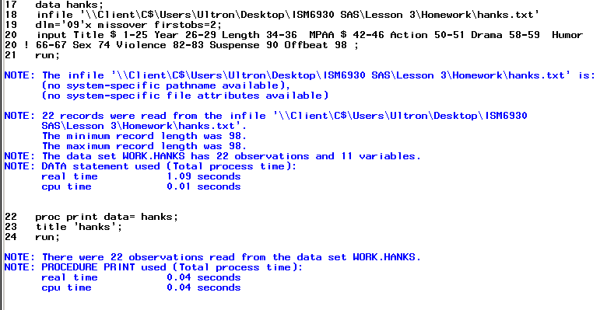

**OUTPUT**

